**Human Resource Information System for Department of Interior and Local Government of the Cordillera Administrative Region (DILG-CAR)**

An IT Project Proposal

Presented to the

Faculty of the School of Computing and Information Sciences

Saint Louis University

In Partial Fulfillment

of the Requirements for the Course

IT 411

by

Arvince Neil A. Alcaide

Sarah Mae E. Centino

Denver D. Culbengan

Ryan Christian A. De Guzman

Danielle Phillip A. Estrellado

Aerhielle Cassandra E. Leonen

Paul Christian C. Sam

Benedict M. Suarez

Laurence F. Balmeo

Project Adviser

December 2017

**Abstract**

Offices in general has difficulties in monitoring, tracking and updating different files and documents mostly offices that still utilize manual processes hence requires effective information management. Information Management guarantees information can be accessed easily and let the users manipulate, track and monitor files and documents fluently. Since the Human Resource and Records Section (HRRS) under the Finance & Administrative Division (FAD) of the Department of Interior and Local Government Cordillera Administrative Region (DILG-CAR) face these difficulties in keeping manual records and managing paper-based records, the developers will create a web application that helps the management and monitoring of files and documents of the said government section.

The developers will utilize the methodology Evolutionary-exploratory Model which ensures the understanding of the requirements, the steady progress of the proposed system and the constant feedback of the client which helps the developers to produce the desired product.

The Human Resource Information System (HRIS) that will be developed for the HRRS will assist the employees in managing and tracking specifically the Personal Data Sheet (PDS), Leaves, Service Record, Notice of Step Increment (NOSI), Notice of Salary Adjustment (NOSA) and updating of Plantilla. Also, some manual processes will be computerized to maximize the effectiveness of the system.

**Table of Contents**

**ABSTRACT …………………………………………………………………………… ii**

**LIST OF FIGURES ………………………………………………………………….. v**

**LIST OF TABLES …………………………………………………………………… vii**

**CHAPTER 1: INTRODUCTION**

1.1 Context of the Study ……………………………………………………… 1

1.2 Background of the Study ………………………………………………… 1

1.3 Statement of the Problem ………………………………………………… 9

1.4 Statement of the Objectives ……………………………………………… 10

1.5 Scope of the Project ……………………………………………………… 10

1.6 Significance of the Study ………………………………………………… 10

1.6.1 To the Employee ………………………………………………. 10

1.6.2 To the HRRS ……………………….………………………….. 10

1.6.3 To the DILG-CAR …………………………………………….. 11

**CHAPTER 2: METHODOLOGY**

2.1 Requirement Gathering ………………………………………………….. 12

2.1.1 Data Gathering ………………………………………………… 12

2.2 Quick Design …………………………………………………………….. 13

2.2.1 Design Tools …………………………………………………… 13

2.2.1.1 Entity-Relationship Diagram ………………………… 13

2.2.1.2 Relationship Database Schema ………………………. 13

2.2.1.3 System Architecture ………………………………….. 13

2.2.1.4 Site Map ………………………………………………. 13

2.3 Building Prototype ……………………………………………………….. 13

2.4 Customer Evaluation …………………………………………………….. 14

2.5 Refactoring Prototype ……………………………………………………. 14

2.6 Final Product ……………………………………………………………... 14

2.7 Timeline of the System …………………………………………………... 15

**CHAPTER 3: OUTCOMES AND RESULTS**

3.1 Requirements Specification …………………………………………….. 16

3.1.1 Functional Requirements ……………………………………… 16

3.1.2 Non-Functional Requirements ………………………………… 17

3.2 System Architecture …………………………..………………………… 18

3.3 Site Map ………….……………………………………………………… 20

3.4 Data Architecture

3.4.1 Entity-Relationship Diagram …………………………………. 22

3.4.2 Data Schema ………………………………………………….. 24

3.5 Prototypes

3.5.1 Human Resource ……………………………………………… 28

3.5.2 Employee ……………………………………………………… 41

3.5.3 Super User ……………………………………………………... 46

**REFERENCES** …………………………………………………………….. 51

**APPENDIX**

Appendix A. Daily Time Record …………………………………… 52

Appendix B. Type of Leaves ……………………………………….. 53

Appendix C. Application for Leave Form ………………………….. 55

Appendix D. Computation of Leaves Credit ………………………. 56

Appendix E. Service Record ………………………………………… 58

Appendix F. Notice of Step Increment ……………………………... 59

Appendix G. Notice of Salary Adjustment …………………………… 60

Appendix H. Leave Ledger Card ……………………………………… 61

Appendix I. Personal Services Itemization and Plantilla of Personnel.. 62

Appendix L. Personal Data Sheet …………………………………… 63

**List of Figures**

Figure 1. HRRS Organizational Chart …………………………………………………. 2

Figure 2. Processing of Personal Data Sheet …………………………………………… 3

Figure 3. Processing of Employee’s Leave Application ……………………………….. 4

Figure 4. Processing of Employee’s Leave Credits …………………………………….. 5

Figure 5. Updating of Plantilla ………...………………………………………………… 6

Figure 6. Processing of Employee’s Service Record, NOSI and NOSA …..…………… 7

Figure 7. Processing of Employee’s Service Record, NOSI and NOSA ……………….. 8

Figure 8. Evolutionary-Exploratory Model …………….……………………………….. 12

Figure 9. Timeline of the System ……………………………………………………….. 15

Figure 10. System Architecture ………………………………………………………… 18

Figure 11. Employee Module Site Map ………………………………………………… 20

Figure 12. HR Admin Officer Module Site Map ……………………………………… 20

Figure 13. Regional Director Module Site Map ………………………………………. 21

Figure 14. Entity – Relationship Diagram …………………………………………….. 22

Figure 15. Entity – Relationship Diagram …………………………………………….. 23

Figure 16. HR Log In …………………………………………………………………. 28

Figure 17. HR Dashboard …………………………………………………………….. 28

Figure 18. HR Sign up ………………………………………………………………… 29

Figure 19. HR Employee’s Account ………………………………………………….. 29

Figure 20. HR Employee’s Account New Password …………………………………. 30

Figure 21. HR Employee’s Updated Personal Data Sheet*…………………….*………… 30

Figure 22. HR Personal Data Sheet of Employee…………………………………….. 31

Figure 23. HR Pending Employee ……………………………………………………. 31

Figure 24. HR Pending Employee ………….………………………………………… 32

Figure 25. HR Employee …………………………………………….………………… 32

Figure 26. HR Employee Profile ……………………………………………………… 33

Figure 27. HR Employee Profile ……………………………………………………… 33

Figure 28. HR Edit Report …………………………………………………………….. 34

Figure 29. HR Edit Report …………………………………………………………….. 34

Figure 30. HR Reports …………………………………………………………………. 35

Figure 31. HR Reports CoE ……………………………………………………………. 35

Figure 32. HR Reports CoE ………………………………………………………….…. 36

Figure 33. HR Pending Leave ………………………………………………………….. 36

Figure 34. HR Application for Leave ………………………………………………… 37

Figure 35. HR Plantilla …………………………………………………………………. 37

Figure 36. HR Salary Grade ……………………………………………………………. 38

Figure 37. HR Previous Salary Grade …………………………………………………. 38

Figure 38. HR Add Salary Grade ………………………………………………………. 39

Figure 39. HR Plantilla Division ……………………………………………………..... 39

Figure 40. HR Plantilla Edit …………………………………………………………… 40

Figure 41. HR Plantilla Promotion and Demotion …………………………………….. 40

Figure 42. HR Plantilla Archive ……………………………………………………….. 41

Figure 43. Employee Reset User Password…………………………………………….. 41

Figure 44. Employee Dashboard ………………………………………………………. 42

Figure 45. Employee Profile …………………………………………………………… 42

Figure 46. Employee Personal Data Sheet …………………………………………….. 43

Figure 47. Employee Edit Personal Data Sheet ……………………………………….. 43

Figure 48. Employee Application Leave Form ………………………………………… 44

Figure 49. Employee Leave Summary …………………………………………………. 44

Figure 50. Employee Service Record …………………………………………………… 45

Figure 51. Employee Notification ……………………………………………………… 45

Figure 52. Dashboard …………………………………………………………………. 46

Figure 53. Dashboard What’s New …………………………………………………….. 46

Figure 54. Employees ………………………………………………………………….. 47

Figure 55. View Employee Details ……………………………………………………… 47

Figure 56. Personal Data Sheet of Employees …………………………………………. 48

Figure 57. Service Record of Employee ………………………………………………… 48

Figure 58. Plantilla …………………………………………………………………….. 49

Figure 59. New Plantilla Setup …………………………………………………………. 49

Figure 60. Leave Reports ……………………………………………………………….. 50

Figure 61. View Leave Reports ………………………………………………………… 50

**List of Tables**

Table 1: Functional Reguirements ……………………………………………………… 16

**Chapter 1: Introduction**

* 1. **Context of the Study**

Human Resource Information System (HRIS) is a system used to acquire, store, manipulate, analyze, retrieve and distribute information regarding a section like Human Resources by providing ease in compiling and finding certain documents in future need within the organization (Michael J. Kavanagh and Richard D. Johnson, 2018).

The proposed system focuses on Human Resource and Records Section (HRRS) of the Department of Interior and Local Government of Cordillera Administrative Region (DILG-CAR). HRRS is a section that handles the informational documents of the office which represents the memory of an organization providing tangible evidences of an organization activities and transactions, employee benefits, redeployment, termination, job description, information of employees and the likes.

DILG-CAR assists and advise the president promulgation of policies, regulation, programs, and projects to promote peace and order, close general supervision for local governments, promotion of autonomy and community empowerment with a consistent monitor of compliance thereof (DILG, 2013).  Furthermore, DILG-CAR functions in organizing and training primarily for the performance of police functions, a police force that is national in scope and civilian in character. With the use of the information maintains and handheld by the HRRS it strengthens the decision making of DILG-CAR, it will support on how DILG-CAR will act concerning the matter. Elective Local Officials Profile Database System (ELOPDS) has a database where the DILG Field Officers encode the personal data sheets of the governors, vice governors, mayors, vice mayors, and councilors of different provinces, municipality, and cities in all over the Philippines.

* 1. **Background of the Study**

Under the Finance and Administrative Division (FAD) of DILG-CAR is the Human Resource and Records Section (HRRS) which handles the informational documents that are used in the organization, the regional office has 32 employees. This informational documents contains information about employees, wages and salary, training and development, promotion, termination and many other information about personnel records. The HRRS specifically handles the Personal Data Sheet (PDS), Daily Time Record (DTR), Service Records, Notice of Step Increment (NOSI), Notice of Salary Adjustment (NOSA), Leave Ledger Card, Application for Leave of the employee and the Personal Services Itemization and Plantilla of Personnel (PSIPOP) or Plantilla of the DILG-CAR.

Most of the documents are still being handled manually and are still paper-based, the HRRS is also using productivity tools like Microsoft Word and Microsoft Excel to manually compute data, digitally store the information regarding about the documents, and generate, edit and update reports. Every employee has a Microsoft and Excel file that are named after them, the files are reports about that specific employee. Regardless with the manual processes in the regional office, ELOPDS is one of the automation process the office has.

|  |
| --- |
| **FINANCE and ADMINISTRATIVE DIVISION (FAD)** |
| Chief Administrative Officer |
| Supervising Administrative Officer |

|  |
| --- |
| **HUMAN RESOURCE and RECORD SECTION (HRRS)** |
| Administrative Officer V (HRMO)  (HR Admin Officer) |
| Administrative Officer IV |
| Administrative Officer IV |
| Administrative Aide IV |
| Administrative Aide IV |

*Figure 1: HRRS Organizational Chart*

The following figure *(see Figure 1)* shows the structure of the HRRS in DILG-CAR and the relations and relative ranks of their positions.

The following are the current process of HRRS in DILG-CAR:

1. Processing of Personal Data Sheet (PDS) – The PDS form has (4) pages, these pages contain information of the employee’s personal information, family background, educational background, civil service eligibility, work experience, voluntary work, training program, and other information as entitled in the PDS form. If there are information needed to be change in the PDS, the employee must fill up a new PDS form and to be submitted to the HR Admin Officer. Each employee must submit their PDS annually whether there is a change or not, then the collected PDS will be part of the 201-Report that will be submitted to the Central Office by the HR Admin Officer. 201-Report is referred to all information of the employees (e.g., appointments, contracts, actions, orders and other information). As a result, the HRRS receives a large number of documents that must be checked individually. As a result, the HRRS receives a large number of paper-based documents that must be check individually and manually.

File/Update

PDS



DILG-CAR Employee

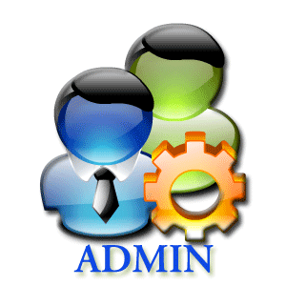

DILG-CAR HR Admin



Filing Cabinet

Submit to HR

Return for correction/s



PDS

Store Validated PDS

*Figure 2*

1. Processing of Employee’s Leaves Application – These are the leaves that an employee of DILG-CAR can avail; Paternity Leave, Rehabilitation Leave, Terminal Leave, Special Emergency Leave, Force Leave, Sick Leave, Vacation Leave, Maternity Leave, Magna Carta for Women, Study Leave, Special Privilege Leave, Solo Parent Leave, Monetize Leave and Violence Against Women and Children Leave. The process starts by filling up a leave application and to be submitted to the HR Admin Officer. The application will be officially approved by the authorization of the HRRS, Department Officer and the RD.

Leave App



DILG-CAR Employee



DILG-CAR HR Admin



Filing Cabinet

Submit to HR

Return for correction/s

Status of Application

Submit to Officer in Charge



DILG-CAR Officer



DILG-CAR Regional Director

Submit to RD

Store Approved App Leave



Application for Leave

*Figure 3*

1. Processing of Employee’s Leave Credits - leave points are given to employee’s every first working day of the month, leave points will be consumed when an employee files an application for leave and renders the given leave, the remaining points will be computed as leave credits. Remaining leave credits of the last month will be added to the leave credits of the next month and so on and so forth. When the leave credits are not consumed it will accumulate and will be converted into cash when an employee files a resignation. An employee can borrow leave points from vacation leave credit to sick leave credits but not vice versa. When an employee consumed all the leave credits and still files a leave and renders it, the salary of the employee will be deducted base from the number of days of the leave. The HR Admin Officer manually store and computes the leave credits of each employee in a spreadsheet file entitled Leave Ledger Card (see Appendix), some data needed for the computation are in the DTR and Leave Form.

Request for Leave Ledger



DILG-CAR Employee



DILG-CAR HR Admin



Filing Cabinet



Leave Ledger

Store Leave Ledger

Retrieve Leave Ledger

*Figure 4*

1. Updating of Plantilla - The Plantilla (see Appendix K) is being released by the Department of Budget and Management (DBM) every start of the year and will be use by the HR Admin Officer all throughout the year. Afterwards the HR Admin Officer will send an updated version of the Plantilla to the DBM through the Government Manpower Information System (GMIS) official website every end of the year for documenting purposes. The Plantilla is a form that monitors the employee’s status in the DILG-CAR, it holds the entire population of DILG-CAR. Every time an employee is either promoted or re-assigned, the Plantilla will be the first to be updated. If there are changes within Plantilla, it will reflect on the reports connected in the Plantilla such as the PDS and Service Record. Changes made in the Plantilla are done manually using a spreadsheet. The HR Admin Officer often uses the cut and paste method to obtain the information of a certain employee in the Plantilla, this is done to transfer the employee’s information to the designated vacant position in the Plantilla. By using spreadsheet to do the process of promoting and re-assigning makes the work longer and arduous because in every Division of the Plantilla has its own different spreadsheet file. When an update occurs the HR Admin also needs to manually update the forms related to the Plantilla.

PDS

Update both PDS and Service Record

Updated Plantilla

Sent to DILG-CAR HRRS



Plantilla

Changes, updates in Plantilla



Filing Cabinet

Store Plantilla

DBM



DILG-CAR HR Admin



Plantilla



Service Record



New Plantilla

*Figure 5*

1. Processing of Employee’s Service Record, NOSI and NOSA– Service Record serves as the summary of the whole working experience of a government employee in the DILG-CAR. Each employee’s service record is stored in a word document file named after them, a hard copy of the report can be requested from the HR Admin Officer. Data from the Service Record are acquired from the Plantilla, which means that if the employee is promoted or reassigned in the Plantilla the Service Record of that employee will be updated as well, also the release of NOSA or NOSI will affect the Service Record. In this case, updating of Service Record will be arduous and will take longer because if either the NOSA or NOSI or Plantilla will be updated the HRRS will check the updated files and manually update the service record of each employee. NOSA is Notice of Salary Adjustment which is being released when the National Budget Circular of the DBM order for salary adjustment and NOSI is Notice of Step Increment will be released when an employee is qualified for a promotion or an employee completed a three (3) years of working service on the same position. The NOSA will be release by the DBM to the HR Admin Officer and will disseminate to each employee. The HR Admin Officer will manually edit the given templates by the DBM for each employee regarding their NOSI and NOSA. Salary Grade is a table that contains the different levels of salary an employee can have, starting from salary grade 1 to salary grade 28.

Request for Service Record



DILG-CAR Employee



DILG-CAR HR Admin



Filing Cabinet



Service Record

Store Leave Ledger

Retrieve Leave Ledger

*Figure 6: Service Record*



Service Record



DILG-CAR Employee



Plantilla



NOSI

Release NOSI

Update Service Record

Update Plantilla

Inform Employee

*Figure 7: NOSI*



Service Record



DILG-CAR Employee



NOSI

Sent to DILG-CAR

HRRS

Update Service Record

Update Plantilla

Inform Employee



Plantilla



DILG-CAR HR Admin

Release NOSA



Philippine Government

*Figure 8: NOSA*

* 1. **Statement of the Problem**

1. The information that the employees are entering in their PDS is not always accurate.

2. The employees who attended seminars and trainings are difficult to monitor due to their outdated PDS.

3. The employees who leave on the different days and currently on their leaves are difficult to monitor.

4. The HRRS uses a Microsoft Excel to have the computation of every employee's leave credits.

5. The HRRS uses a Microsoft Excel to monitor the Plantilla and they use copy and paste method to have a history of their Plantilla.

6. In generating the employee's Service Record, NOSI and NOSA typographical error is a common error that employee are encountering.

The system will be a web application that employees and the HRRS can be access from the office. The system will have a login system to secure the information of the employee and the HRRS. The new user will have to input the first part of the PDS which is the personal information section. The main processes of our system are to view, edit, and generate the following:

1. PDS – in the system, the process of the PDS is almost similar to the current process of DILG-CAR except in the system, the process is computerized and does not have to be print. The PDS in the system can be view and edit by the employee anytime there is an update in their PDS and can be print if needed. The HRRS can now easily check the update of their PDS.
2. Leave Application – there will be a template for the application which an employee can fill up and print afterwards then submit the printed file to the HRRS. After the HRRS checked the form, it will be delivered to the employee’s department head then to the RD to be approved. If approved by both then it will be marked in the system approved. This will help the HRRS to monitor the leave of their employee.
3. Leave Ledger – the system can query some information of the employee to create their leave ledger.
4. Plantilla – the Plantilla can be edit, view, and generate by the HR admin Officer. The Plantilla in the system will have a function of promoting and re-assigning a certain employee and can archive employee too.
5. Service Record – some of the data will be query from the service experience in the PDS and the update will come from the Plantilla.
6. NOSI and NOSA – there will be templates for NOSI and NOSA in the system and certain data’s can be query to supply some information
   1. **Statement of the Objectives**

The objective of the project is to develop the HRIS, to automate manual working related processes between Employee and the Human Resource Administrator, and improve monitoring and checking of processes by the HRRS.

* To collect and determine the requirements by gathering data that is significant in the development of the HRIS System
* To establish this different architecture and models in designing the system which are the Application and System Architecture, Entity Relationship Diagram and Data Schema
* To implement the design by using different tools and technologies.
* To present the system functions and feature through performing beta testing with different users.
* To maintain and deploy the system.
  1. **Scope of the Project**

The proposal of this project is to improve the system of the HRRS in the DILG-CAR. The developers conducted a requirement elicitation and analysis of the current condition of the regional office of DILG-CAR to collect data needed for the functional requirements of the HRIS for DILG-CAR and the following processes are observed as follows; processing of Personal Data Sheet, processing of employee's work time, processing of employee's leaves, processing of employee's leave credits, maintaining of the Plantilla, processing of employee's Service Record, NOSI, and NOSA. The proposed system will not include the Daily Time Record of the employee.

* 1. **Significance of Study**

**1.6.1 To the Employee**

It would make the work of employees easier and more convenient. The employees can view their PDS, Leaves, Service Record, NOSI, NOSA and Plantilla. Also, they can edit the PDS and file a leave via the system.

**1.6.2 To the HRRS**

It would help the human resource personnel to facilitate and monitor changes or updates regarding information in the system. Tracking, organizing, sorting data and generating reports will be faster and easier.

**1.6.3 To the DILG-CAR**

It would help the DILG-CAR to have faster operations in HRRS and make significant change in the processes involving in the particular section.

**CHAPTER 2**

**Methodology**

The methodology that the developers will use for the development of the system is the Evolutionary-Exploratory Model. With requirements that are constantly changing throughout the development of the system using the model is suitable for the project. By using this model, the developers will be able to understand much better the process and purpose of each part in different forms of the HRRS to make development more effective. Through analyzing the gathered data, frequent interviews with the HRRS and observing the current process the developers narrow down the essential requirements, and create features and modules. The developers design a diagram to explain the phases for the development of the system.



*Figure 8*

With the phases of the model (see Figure 8), the developers are improving and making changes with every iteration that is being made thus achieving the desired final product.

**2.1 Requirement Gathering**

The requirement gathering phase allows the developers to fully understand the demands and wants of the stakeholders, also can give a better grasp on what will the whole project can offer. Thus, making this phase critical to the development of the project. The developers must be thorough and concise on the information that will be gathered, the developers will gather information by interview, document analysis, observation and data gathering.

**2.1.1 Data Gathering**

The methods that the developers will use in gathering data are interviews, observation of the HRRS current processes, analyzation of different forms and documents.

The developers scheduled interviews with the Administrative Officer of the HRRS to fully understand their process and clarify information that is unclear, they asked the step by step process of different forms, problems and concerns occur in the office, explanation of different forms related to other forms, and how the system should process and the outcome of the forms generated by the system. The developers will also make an observation on the working area of the HRRS that will help the developers to have a good grasp on how the actual process work. Sample copies of reports and user records were also collected so that the developers may have a very good understanding about the content and the processes of the client’s work.

The developers will also base the interface of the system with the website ELOPDS which is suggested by RITCTU. ELOPDS has most of the functionalities to be used in the system, also RITCTU gave the theme to be followed.

**2.2 Quick Design**

In the quick design phase, the developers create design the back-end and the front-end of the system. This design is based on the requirements that will be gather in the requirement phase and the requirement or suggestion of the HRRS.

**2.2.1 Design Tools**

**2.2.1.1 Entity-Relationship Diagram**

The Entity-Relationship diagram will be used by the developers to represent the information system for DILG’s daily monitoring of work and to show the relationships between entities in the database.

**2.2.1.2 Relationship Database Schema**

This will support the ERD used by the developers, it will describe the data or information that is stored in the database. The schema represents the view of the entire database including its constraint to specify the rules for data in a table.

**2.2.1.3 System Architecture**

Application Architecture will be used in the development of the system to define the framework and structure of the organization’s application. It establishes the framework for agility, reliability, and scalability in the application system so that the application will respond effectively and efficiently to changes in the important information systems. And it defines the necessary application systems to process data and support solutions for the business requirements. It also shows how this application communicates with each other and to its users.

**2.2.1.4 Site Map**

Site Map will be used for the planning of the proposed web-based system and also to list the webpages of the proposed system.

**2.3 Building Prototype**

The prototype phase is the start of development of the quick design that is created by the developers. The developers will develop the prototype based on the current requirements and data gathered. The developers work both front-end and the back-end of the system.

**2.4 Customer Evaluation**

The client evaluation phase is where the client evaluates the system created by the developers. The people who will evaluate are from the HRRS or Regional Information & Communication Technology Unit (RITCTU) of the DILG-CAR. The software testing will be validation testing and the testing approach is black box. The client will give the developers feedback about the system. The evaluation will start by developers explain the progress of the system, then testing of data input in the system and see the output, finally recording the results of the evaluation. It will be repeat on Monday every week if both developers and client is available.

**2.5 Refactoring Prototype**

The refactoring prototype phase is where the developers refactors or update the system from the feedback of the client. After the client does the evaluation, if the client sees problems, a system error occurs or the client wants minor changes in the system or in some cases the developers found bugs then the developers will list it. Then the developers will fix the problems and the bugs then updated system to present it to the client. Then list all the update and added to new quick design and iterate the process.

**2.6 Final Product**

After all the building of prototype, evaluation, and refactoring to attain the system required, the final production phase will start. In this phase, the developers will present it to the whole employee of the DILG – CAR main office to demonstrates it to them so that they know how to use the system. The developers also make a manual of the system to help the employees and the HRRS how to use the system.

**2.7 Timeline of the system**



*Figure 9*

**Chapter 3: Outcomes and Results**

**3.1 Requirements Specification**

Table 1: The following are the list of functional requirements provided by the system.

|  |  |
| --- | --- |
| Employee | * Will be able to modify their personal information in the PDS * Will be able to view their PDS * Will be able to update their PDS * Will be able to input their leave information * Will be able to file their leave application * Will be able to modify their leave information * Will be able to view their leave information * Will be able to update their leave information * Will be able to view their Service Record |
| HR Admin Officer | * Will be able to generate the PDF file of PDS * Will be able to input data in the Leave Ledger * Will be able to modify leave ledger of employee * Will be able to view the pending and approve leaves * Will be able to view the Leave Ledger of employee * Will be able to update the Leave Ledger of employee * Will be able to accept or reject employee’s file leave * Will be able to print Leave Ledger * Will be able to input data in the Service Record * Will be able to modify the Service Record of employee * Will be able to view the Service Record of employee * Will be able to update the Service Record of employee * Will be able to print Service Record * Will be able to input data in the Plantilla * Will be able to modify personal information in the Plantilla * Will be able to view the Plantilla * Will be able to update the Plantilla * Will be able to select employee to promote, re-assign, or archive in the Plantilla * Will be able to print Plantilla * Will be able to modify the NOSI of employee * Will be able to view the NOSI of employee * Will be to able update the NOSI of employee * Will be able to print the NOSI * Will be able to modify the NOSA of employee * Will be able to view the NOSA of employee * Will be to able update the NOSA of employee * Will be able to print the NOSA * Will be able to view the Certificate of Employment of employee * Will be able to print Certificate of Employment of employee * Will be able to search specific employee profile * Will be able to search, view and filter pending employees * Will be able to select a report to generate |
| Regional Director | * Will be able to view the PDS of employee * Will be able to view the Leave Ledger * Will be able to view the Plantilla * Will be able to view the Service Record * Will be able to view pending and approved leaves |

**3.1.2 Non-Functional Requirements**

The following are the list of how the system should be:

* The system must be able to secure privacy of information
* The performance of the system should be fast; there should be no run-time constraints
* The system should provide accurate and precise data
* The system should be easy to operate and learn
* The system should be able to handle error detection and checking of duplicates
* The system should be able to handle capacity of resources and data to be processed

**3.2 System Architecture**

DILG-CAR Employee



Regional Director

DILG-CAR Employees

HR Admin Officer



HRIS for DILG-CAR



NETWORK

NETWORK

MySQL Database



*Figure 10: System Architecture for HRIS of DILG-CAR*

The system that will be develop can be access through a web browser, specifically Google Chrome and Mozilla Firefox. The developers decided the following technologies in developing the system namely HTML, JavaScript and CSS for the front end of the system while for the functionalities the developers have chosen the programming language called PHP together with its framework Laravel. To store the files needed by the system to work, the developers have chosen MySQL and phpMyAdmin in constructing the database of the HRIS of DILG-CAR.

To test the system and to make sure that the system is able to meet its requirement and the desired out is obtained, the following technologies for testing the system will be use are BlackBox and Selenium. These testing tools will test the logical paths of the system and checks if the input is properly accepted and the output is correct.

**3.3 Site Map**



*Figure 11: Employee Module Site Map*

The figure above *(see Figure 11)* shows the list of webpages that the employee can navigate through the web application.

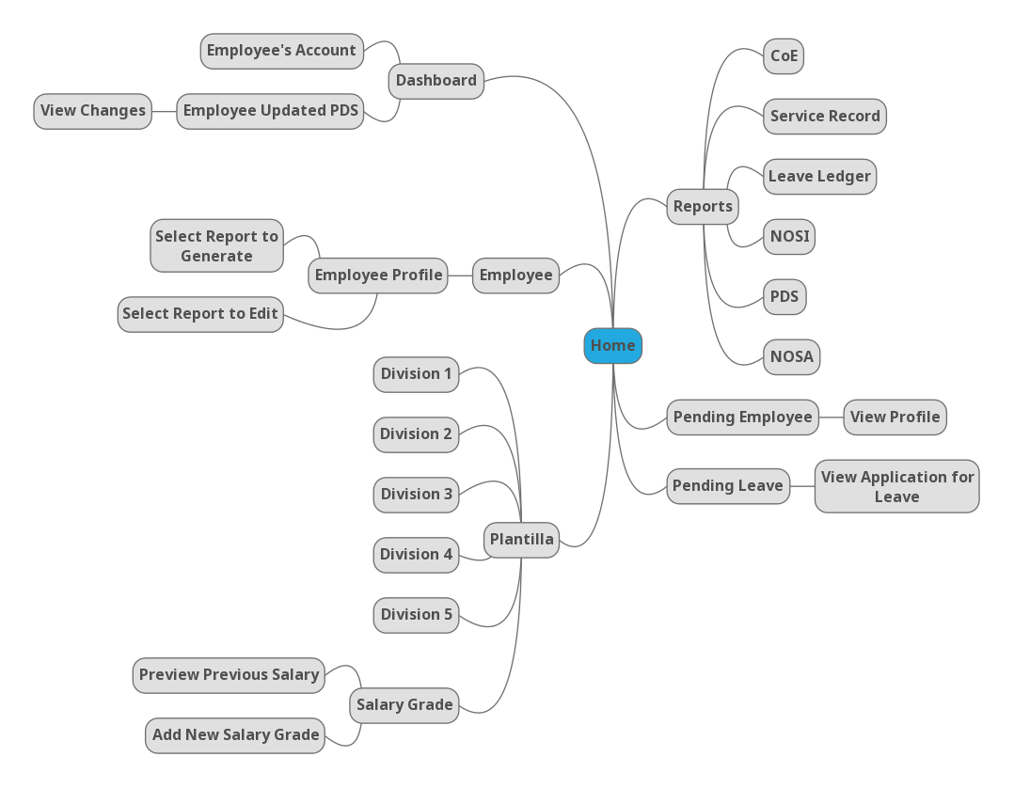

*Figure 12*: *HR Admin Officer Module Site Map*

The figure above *(see Figure 12)* shows the list of webpages that the HR Admin Officer can navigate through the web application.



*Figure 13: Regional Director Module Site Map*

The figure above *(see Figure 13)* shows the list of webpages that the Regional Director can navigate through the web application.

**3.4 Data Architecture**

**3.4.1 Entity-Relationship Diagram**



*Figure 14*



*Figure 15*

**3.4.2 Data Schema**

APPLICATION FOR LEAVE (app_id, emp_id, typeOfLeave, location, sickInfo, noOfWorkingDays, inclusiveDates, status)

FK emp_id References Employee Nulls Not Allowed

Delete Cascade, Update Cascade

AK emp_id

CIVILSERVICE ELIGIBILITY (civilService_id, emp_id, civilServiceName, rating, dateOfExamination, placeOfExamination, licenseNumber, licenseDateOfValidity)

FK emp_id References Employee Nulls Not Allowed

Delete Cascade, Update Cascade

CHILDREN (family_id, fullname, dateOfBirth)

FK family_id References FamilyBackground Nulls Not Allowed

Delete Cascade, Update Cascade

DIVISION (division_id, division_code, division, province)

AK division_code

EDUCATIONAL BACKGROUND (educ_id, emp_id, level, nameOfSchool, basicEducationDegreeCourse, periodOfAttendanceFrom, periodOfAttendanceTo, highestLevelEarnedUnits, yearGraduated, scholarshipsAcademicHonorsReceived)

FK emp_id References Employee Nulls Not Allowed

Delete Cascade, Update Cascade

EMPLOYEE (emp_id, name, dateOfBirth, sex, civilStatus, height, weight, bloodtype, gsis, pagibig, sss, tin, citizenship, ressidentialAddressHouseBlockLotNo, residentialAddressStreet, residentialAddressSubdivisionVillage, residentialAddressBarangay, residentialAddressCityMunicipality, residentialAddressProvince, residentialAddressZipcode, permanentAddressHouseBlockLotNo, permanentAddressStreet, permanentAddressSubdivisionVillage, permanentAddressBarangay, permanentAddressCityMunicaplity, permanentAddressProvince, permanentAddressZipcode, telephoneNo, mobileNo, emailaddress, citizenship_country, citizen_info, password)

AK name

EMPVOLU (voluntaryWork_id, emp_id, position_title)

FK voluntaryWork_id References Voluntary Works Nulls Not Allowed

Delete Cascade, Update Cascade

FK emp_id References Employee Nulls Not Allowed

Delete Cascade, Update Cascade

EMPWORK (workExperience_id, emp_id, year)

FK workExperience_id References Work Experience Nulls Not Allowed

Delete Cascade, Update Cascade

FK emp_id References Employee Nulls Not Allowed

Delete Cascade, Update Cascade

FAMILY BACKGROUND (family_id, emp_id, spouseName, spouseOccupation, spouseEmployerBusiness, spouseBusinessAddress, spouseTelephoneNo, fatherName, motherName)

FK emp_id References Employee Nulls Not Allowed

Delete Cascade, Update Cascade

LEAVE LEDGER (ledger_id, emp_id, app_id, vacationAvailedLeaves, vacationNoOfAbsence, tardiness, vacationEarned, vacationBalance, vacationAbsenceWithPay, vacationAbscencesWithoutPay, sickAvailedLeaves, sickNoOfAbsenceTardiness, sickEarned, sickBalance, sickAbsenceWithPay, sickAbsencesWithoutPay, year)

FK emp_id References Employee Nulls Not Allowed

Delete Cascade, Update Cascade

FK app_id References ApplicationForLeave Nulls Not Allowed

Delete Cascade, Update Cascade

AK emp_id

OTHER INFO (info_id, emp_id, skillsAndHobbies, nonAcademicDistinction, membership)

FK emp_id References Employee Nulls Not Allowed

Delete Cascade, Update Cascade

PLANTILLA (plantilla_id, emp_id, position_id, division_id, itemNumber, positionTitle, salaryGrade, authorized_sal, actual_sal, step_increment, area_code, area_type, level, ppaAttribution, civil)

FK emp_id References Employee Nulls Not Allowed

Delete Cascade, Update Cascade

FK position_id References Position Nulls Not Allowed

Delete Cascade, Update Cascade

FK division_id References Division Nulls Not Allowed

Delete Cascade, Update Cascade

AK emp_id

PDS EMPLOYEE RESPONSE (PdsEmployeeResponse_id, emp_id, no34ResponseA, no34ResponseB, no34ResponseDetails, no35ResponseA, no35ResponseB, no35Details, no36Response, no36ResponseDetails, no37Response, no37Details, no38ResponseA, no38ResponseB, no38ResponseDetails, no39Response, no39ResponseDetails, no40ResponseA, no40ResponseADetails, no40ResponseB, no40ResponseBDetails, no40ResponseC, no40ResponseCDetails)

FK emp_id References Employee Nulls Not Allowed

Delete Cascade, Update Cascade

POSITION (position_id, emp_id, position)

FK emp_id References Employee Nulls Not Allowed

Delete Cascade, Update Cascade

REFERENCES (reference_id, emp_id, name, address, telephoneNo)

FK emp_id References Employee Nulls Not Allowed

Delete Cascade, Update Cascade

SERVICE RECORD (service_id, emp_id, startJobDate, endJobDate, designation, status, annualSalary, division, branch, remarks)

FK emp_id References Employee Nulls Not Allowed

Delete Cascade, Update Cascade

AK emp_id

TEMPLATE (template_id, emp_id, context, date, salary)

FK emp_id References Employee Nulls Not Allowed

TRAININGS (training_id, emp_id, titleofTrainingLearning, trainingStart, trainingEnd, numberOfHouse, typeOfLP, conductedSponsoredBy)

FK emp_id References Employee Nulls Not Allowed

Delete Cascade, Update Cascade

VOLUNTARY WORKS (voluntaryWork_id, emp_id, nameAddressOfOrganization, from, to, position)

FK emp_id References Employee Nulls Not Allowed

Delete Cascade, Update Cascade

WORK EXPERIENCE (workExperience_id, emp_id, startJobDate, endJobDate, positionTitle, departmentAgencyOfficeCompany, monthlySalary, salaryJobPayGradesStep, statusOfAppointment, GovernmentService)

FK emp_id References Employee Nulls Not Allowed

Delete Cascade, Update Cascade

**3.5 Prototypes**

**3.5.1 Human Resource Administrative Officer**



*Figure 16: Log In*

**

*Figure 17: Dashboard*

**

*Figure 18: Sign up*

**

*Figure 19: Employee’s Account*

**

*Figure 20: Employee’s Account New Password*

**

*Figure 21: Employee’s Updated Personal Data Sheet*

**

*Figure 22: Personal Data Sheet of Employee*

**

*Figure 23: Pending Employee*

**

*Figure 24: Pending Employee*

**

*Figure 25: Employee*

**

*Figure 26: Employee Profile*

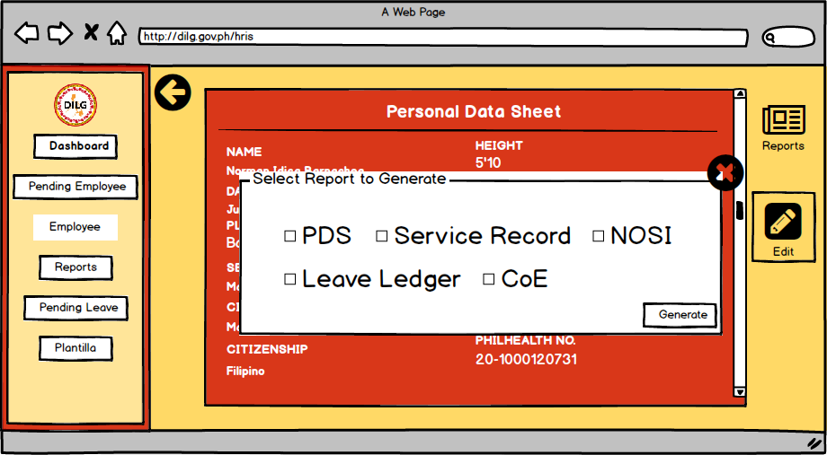

*Figure 27: Employee Profile*

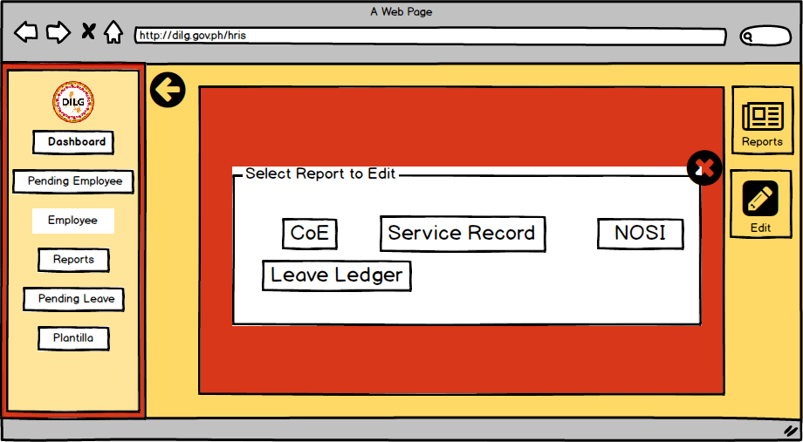

*Figure 28: Edit Report*

**

*Figure 29: Edit Report*

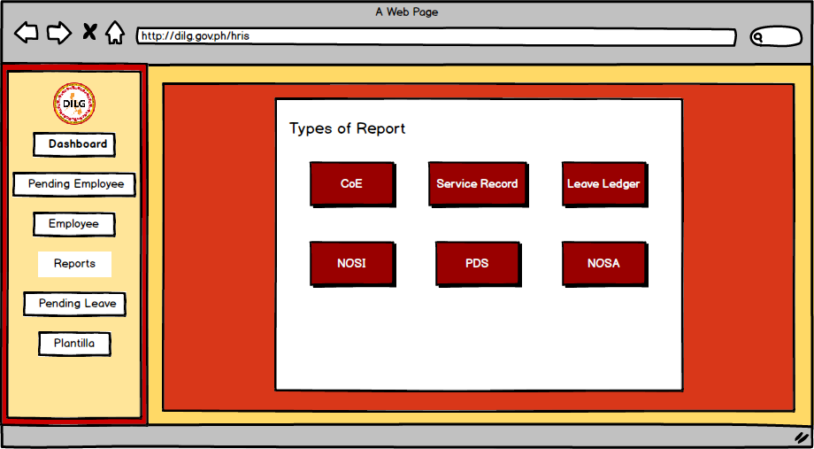

*Figure 30: Reports*

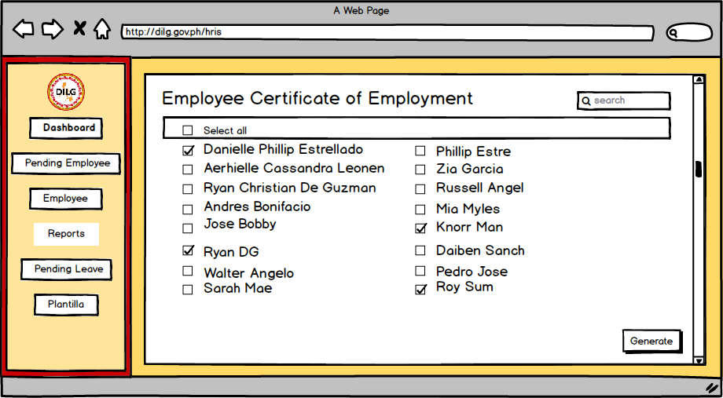

*Figure 31: Reports CoE*

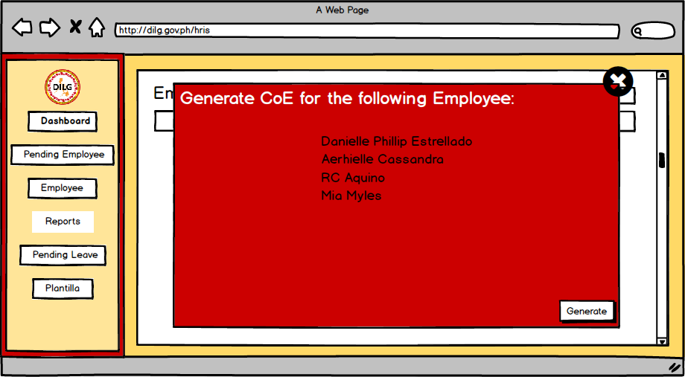

*Figure 32: Reports CoE*

**

*Figure 33: Pending Leave*

**

*Figure 34: Application for Leave*

**

*Figure 35: Plantilla*

**

*Figure 36: Salary Grade*

**

*Figure 37: Previous Salary Grade*

**

*Figure 38: Add Salary Grade*

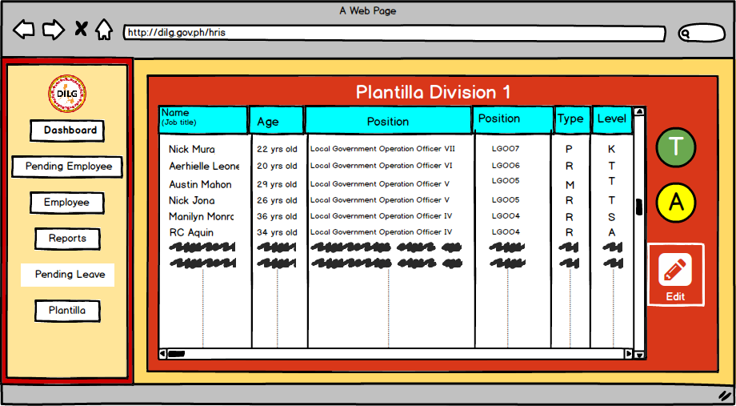

*Figure 39: Plantilla Division*

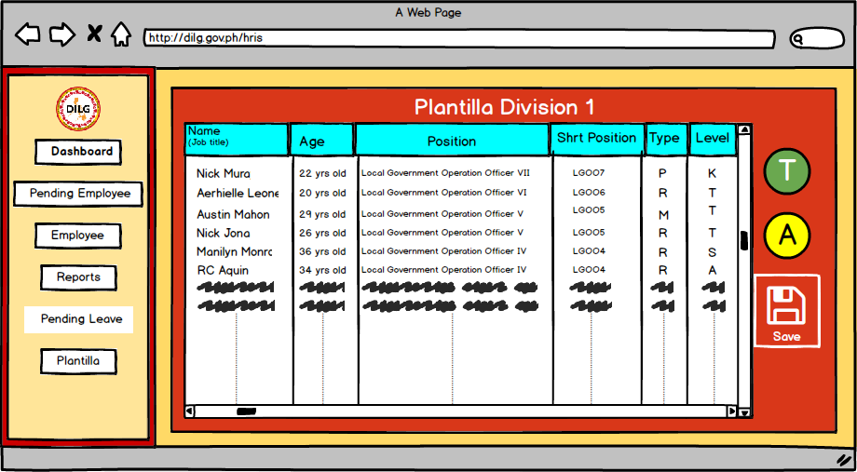

*Figure 40: Plantilla Edit*

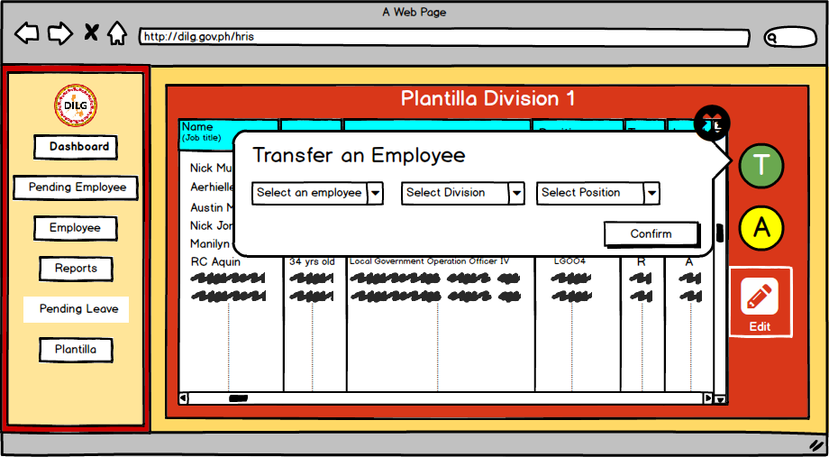

*Figure 41: Plantilla Promotion and Demotion*

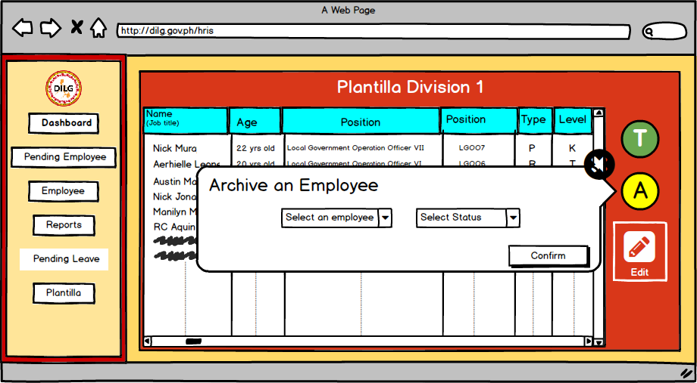

*Figure 42: Plantilla Archive*

**3.5.2 Employee**



*Figure 43: Reset User Password*



*Figure 44: Dashboard*



*Figure 45: Profile*

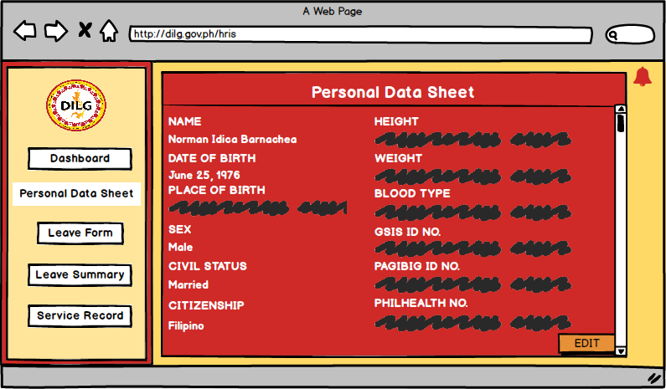

*Figure 46: Personal Data Sheet*

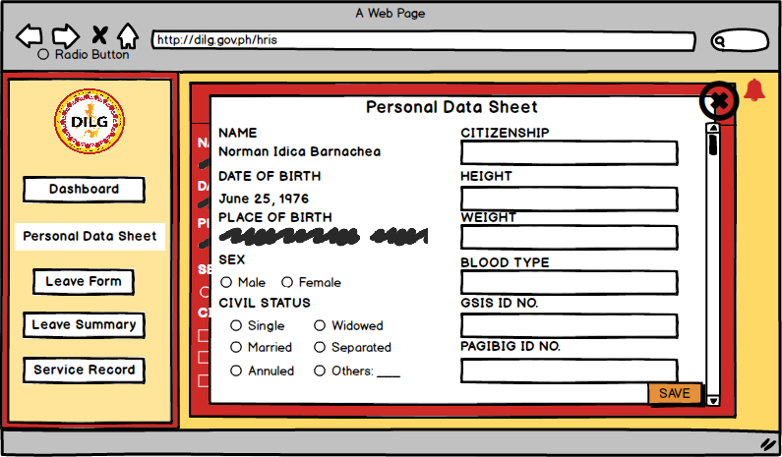

*Figure 47: Edit Personal Data Sheet*



*Figure 48: Application Leave Form*

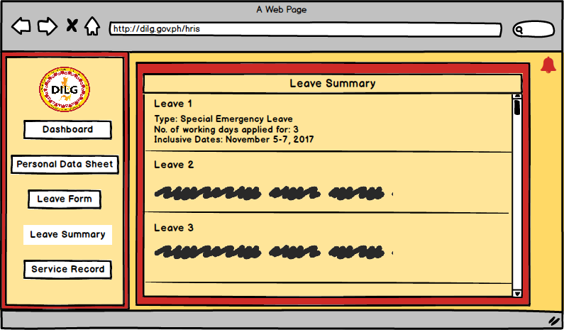

*Figure 49: Leave Summary*

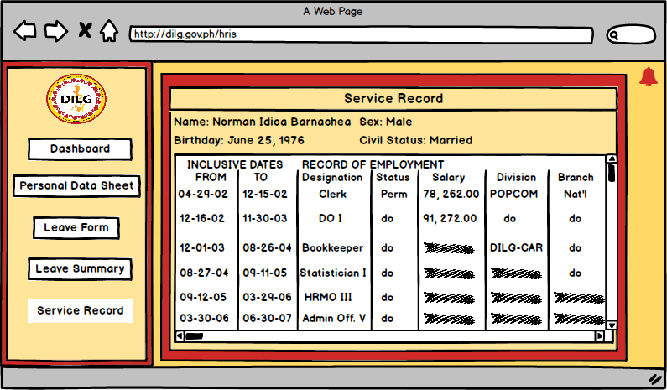

*Figure 50: Service Record*

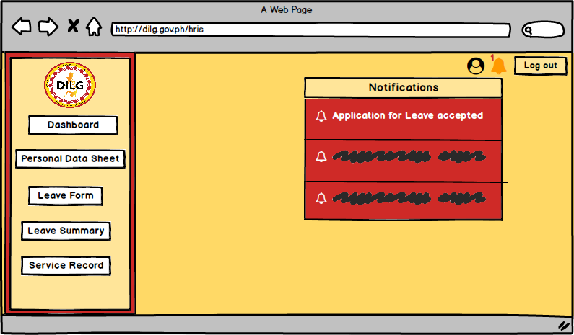

*Figure 51: Notification*

**3.5.3 Super User**



*Figure 52: Dashboard*

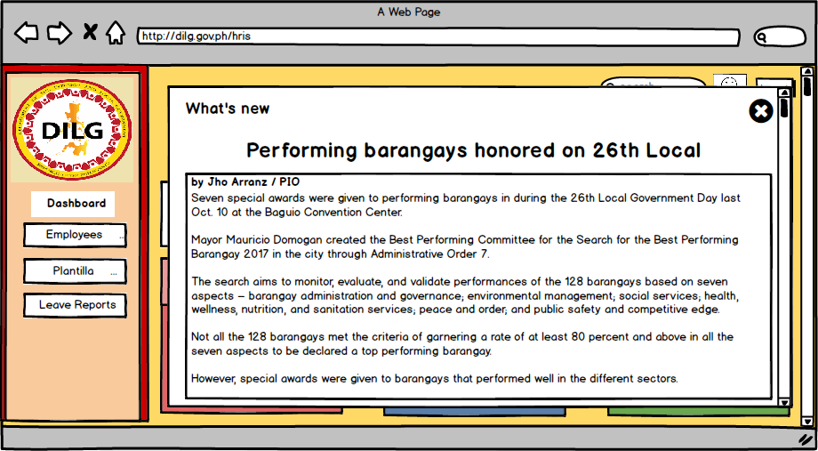

*Figure 53: Dashboard What’s New*



*Figure 54: Employees*

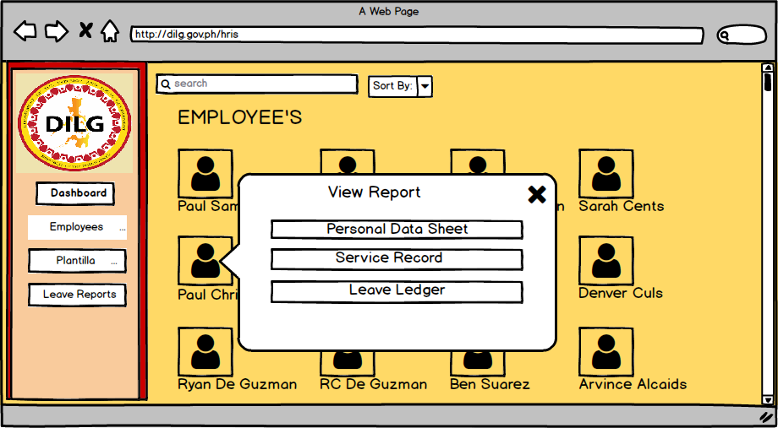

*Figure 55: View Employee Details*



*Figure 56: Personal Data Sheet of Employees*



*Figure 57: Service Record of Employee*



*Figure 58: Plantilla*



*Figure 59: New Plantilla Setup*



*Figure 60: Leave Reports*



*Figure 61: View Leave Reports*

**REFERENCES:**

[1] Human Resources Technology Council (U.S.) and United States Office of Personnel Management. (1997). *Governmentwide human resources information systems study*. Retrieved from

http://www.worldcat.org/title/governmentwide-human-resources-information-systems-study/oclc/38530163&referer=brief_results

[2] Michael J. Kavanagh and Richard D. Johnson. (2014, January 14). *Human Resource Information Systems: Basics, Applications, and Future Directions (4th. ed.)*. Retrieved from

https://books.google.com.ph/books?id=3TxbDgAAQBAJ&pg=PA1&source=gbs_toc_r&cad=2#v=onepage&q&f=false

[3] DILG. (2013). *DEPARTMENT OF INTERIOR AND LOCAL GOVERNMENT: Powers & Functions*. Retrieved from<http://www.dilg.gov.ph/page/Powers-Functions/21>

[4] ISO. *International Organization for Standardization 15489-1:2016: Information and documentation -- Records management -- Part 1: Concepts and principles*. Retrieved from <https://www.iso.org/standard/62542.html>

[5] Rouse, M., Gibilisco, S. (2015, January). *use case diagram (UML use case diagram)*. Retrieved from http://whatis.techtarget.com/definition/use-case-diagram

**APPENDIX**

**Appendix A:** Daily Time Record



**Appendix B:** Type of Leaves





**Appendix C:** Application for Leave Form



**Appendix D:** Computation of Leaves Credit





**Appendix E:** Service Record



**Appendix F:** Notice of Step Increment



**Appendix G:** Notice of Salary Adjustment



**Appendix H:** Leave Ledger Card



**Appendix I:** Personal Services Itemization and Plantilla of Personnel (Plantilla)



**Appendix L:** Personal Data Sheet







